Acecondition website

This is an example

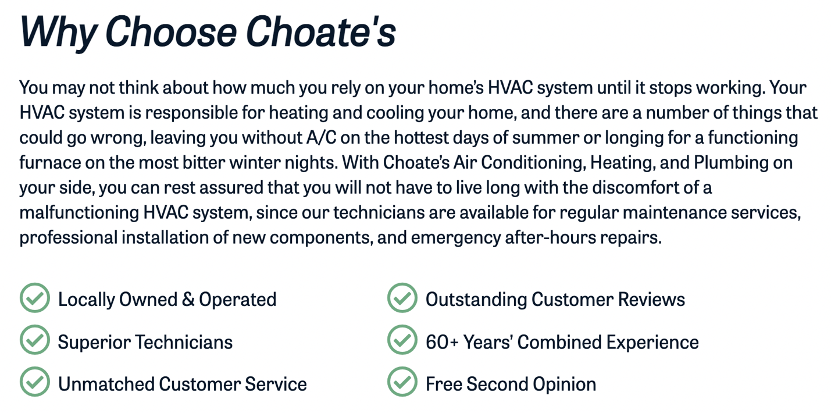

This is how I want my website put I want it to look nicer of course. Similar to how that website above is.



3 slider photos I’ll send you an attachment of them and what to write on the photos.

Choose AceCondition

AceCondition is a locally owned and operated company that focuses on keeping their clients cool in the summer and warm in the winter while also saving them money. Most people don’t realize that if their AC isn’t cooling or warming their house properly, their electricity bill will increase due to an active AC unit or heater that prevents the thermostat from reaching the desired temperature. Our service technicians are trained for these situations.

Everyone should have an HVAC technician service their air condition once a year to keep up with their manufacturer warranty guidelines. This year choose AceCondition to service your air condition.

Locally Owned & Operated Free Installation Quotes

- Affordable Repairs Unmatched Customer Service

- Professional Experience Quick Response

Fill out our form:

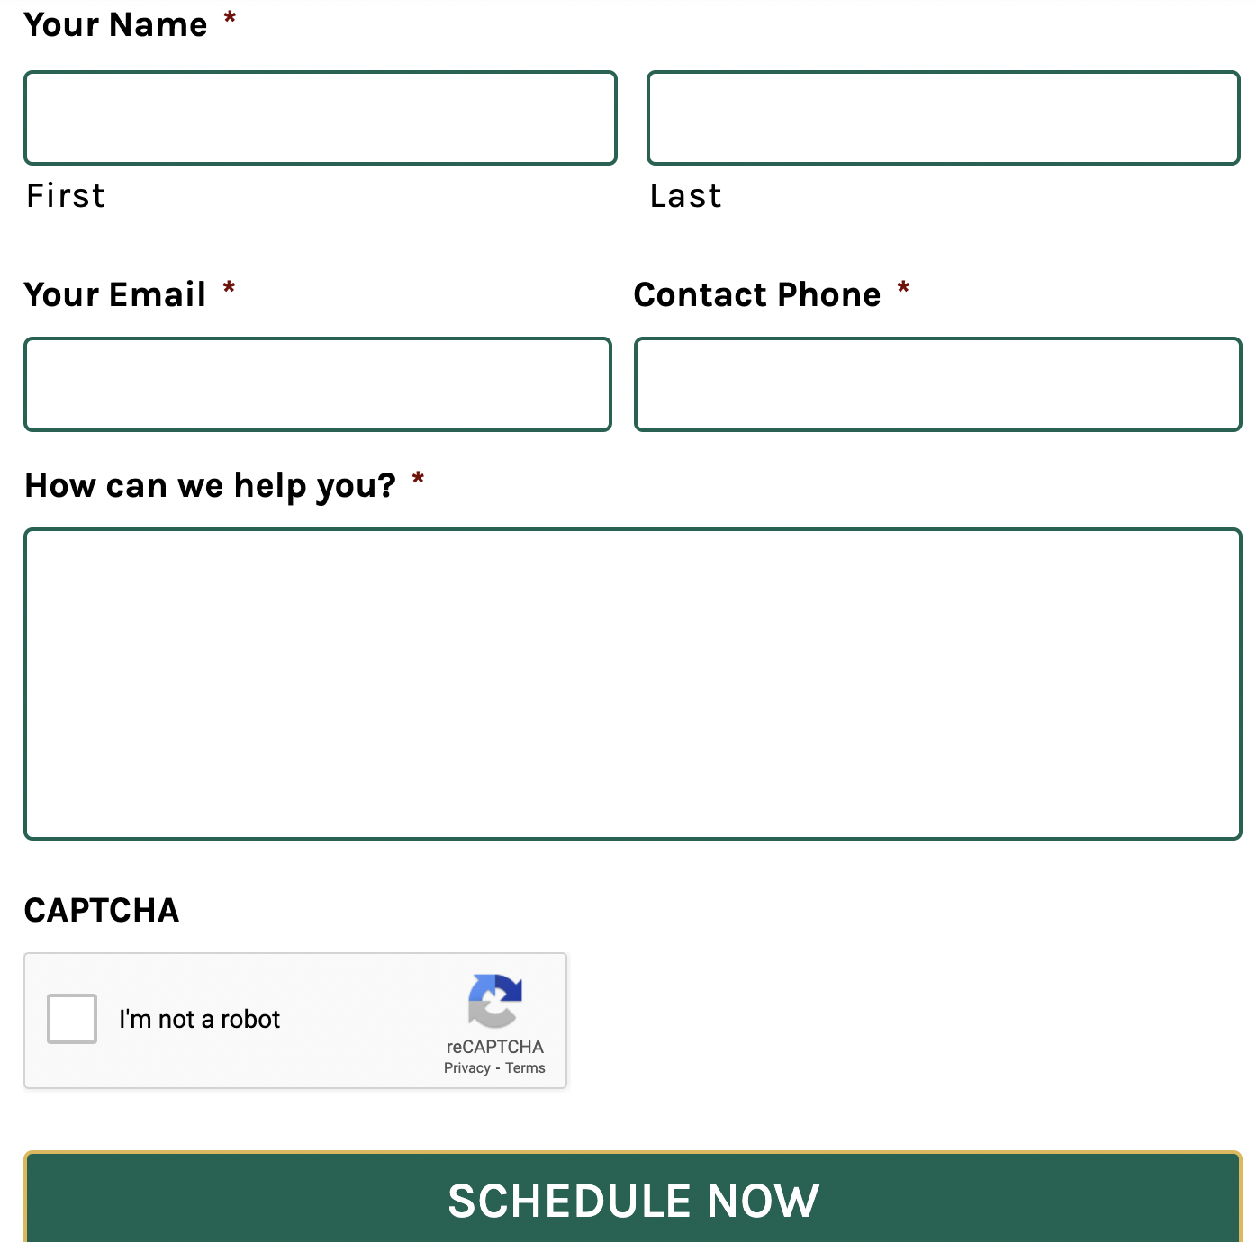

FAQ
Referral

