Best Edvizing Profile as a Student or Subcontractor

Standing out in the freelancing world is essential to securing rewarding job opportunities. Edvizing offers a platform to connect with employers, but your freelancer profile should stand out to draw potential employers to your talent. Here is a walk-through guide to help you build a profile that will attract employers:

1. Edit Your Profile
In this section, you will fill out basic information about yourself and your business. Here is a step-by-step guide to assist you in creating a profile that will capture the attention of employers:

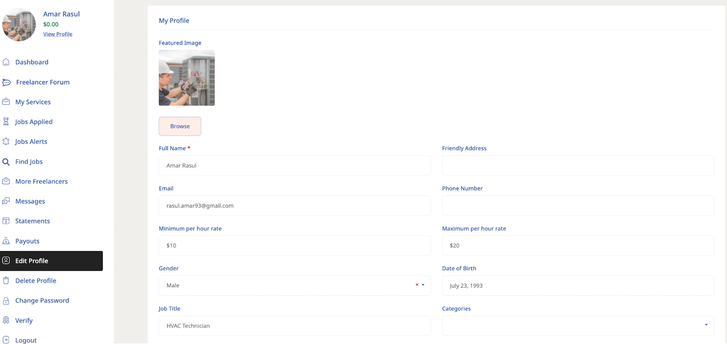

Also in Edit Profile, you can add your Minimum Per Hour Rates All of this information will show up once you click on View Profile, or when someone clicks on your profile. Here is an example:
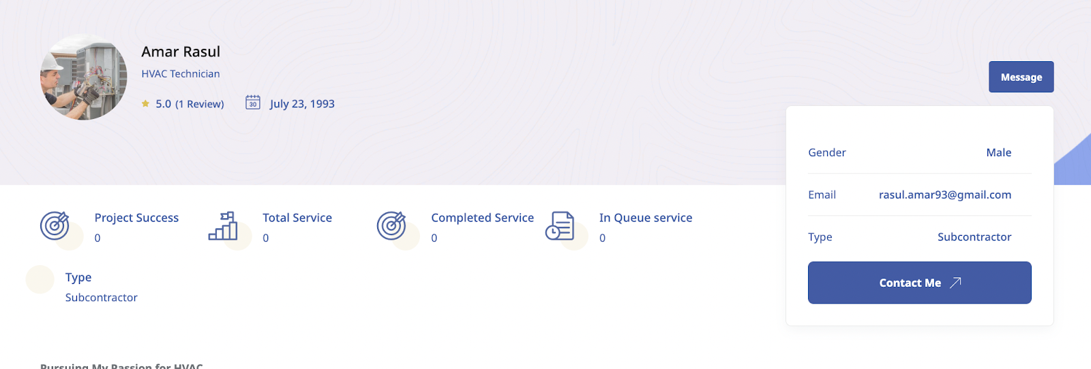

2. Craft a Personal Statement
A well-written personal statement or cover letter can greatly improve your prospects of connecting with the right employer. It does this by adding a personal touch to the details you've shared in your profile. This tool gives you the opportunity to introduce yourself, showcase your strengths, specify the positions you're interested in taking on, and explains why you'd be an excellent addition to their team.
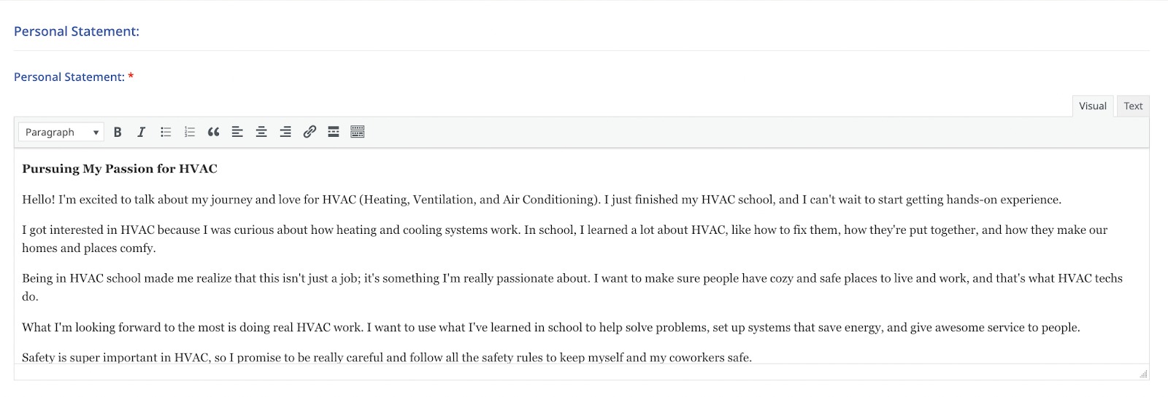

Here’s an example of a short, yet impactful personal statement:
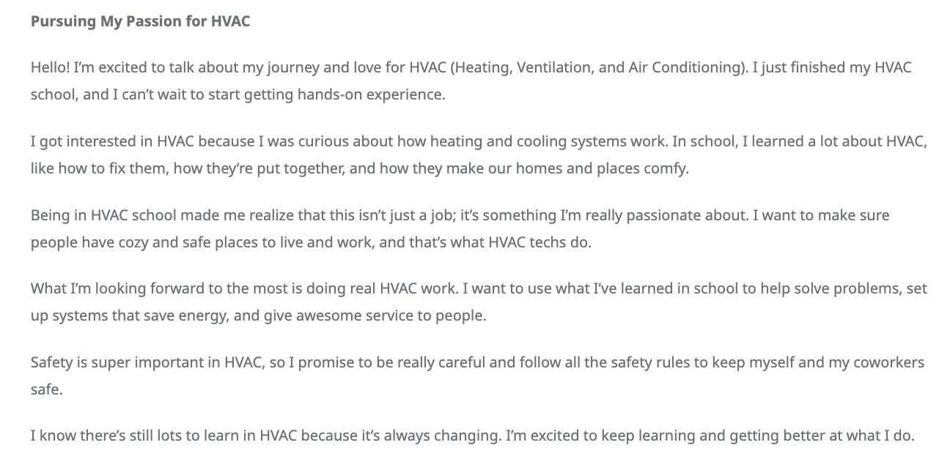

3. Showcase Your Education:
Education plays a crucial role in our personal growth and professional advancement. In this section, you should provide a resume and cover letter to emphasize your academic accomplishments and how they have influenced your path toward a career.

Add a Resume, and/or relevant degrees or certifications, here: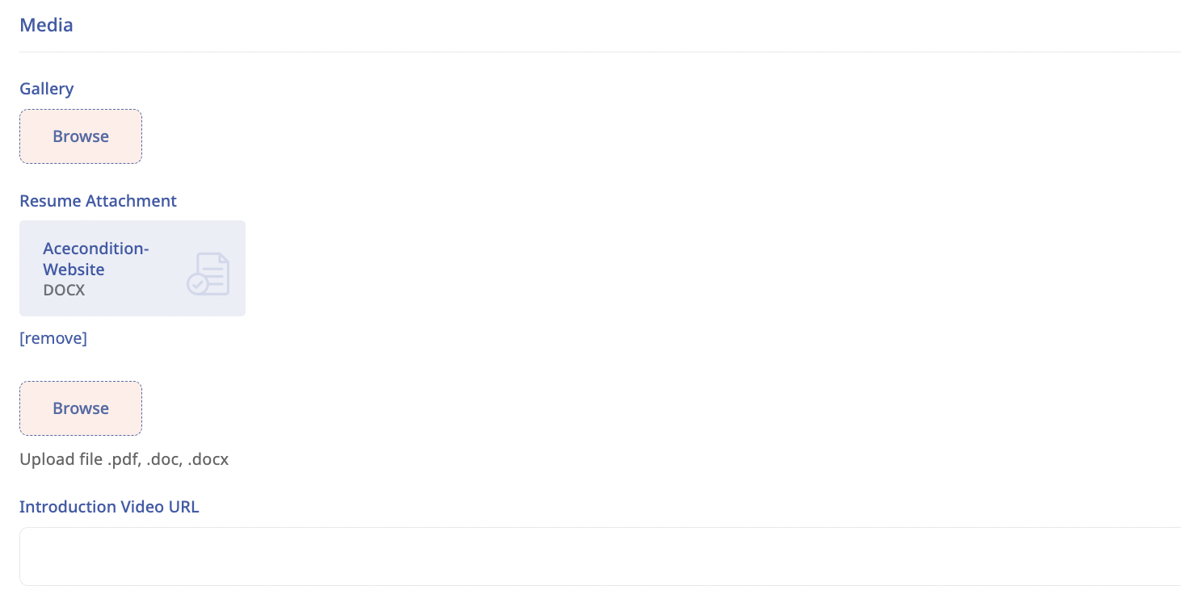

Insert relevant education here:

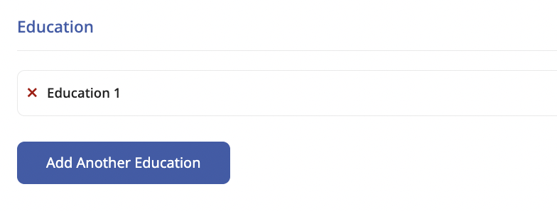

This is what your Education and Work Experience sections will look like to employers:
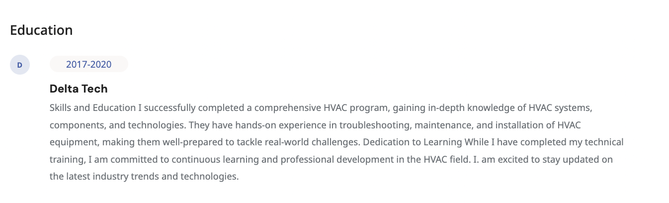

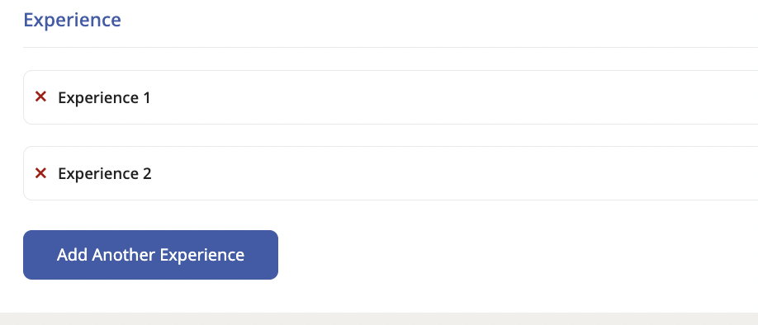

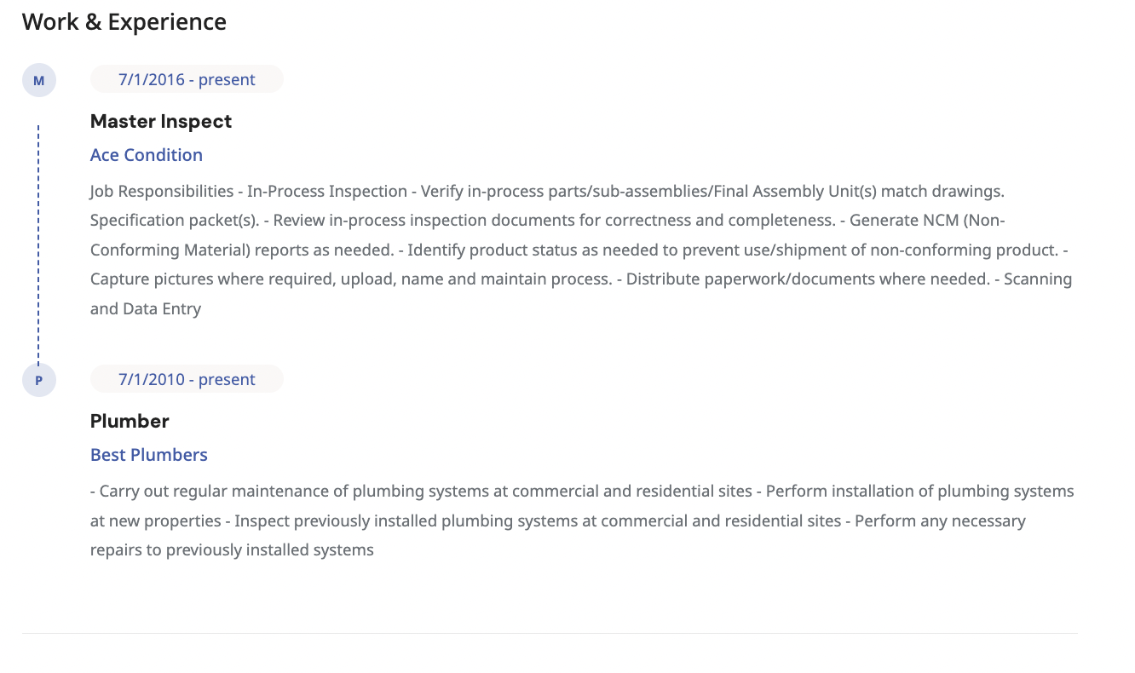

4. Highlight Relevant Industry-Related Skills
This section focuses on showcasing the skills that are directly applicable and valuable within your industry or career field. By emphasizing these skills, you will demonstrate your qualifications and readiness to be trained and employed by employers.

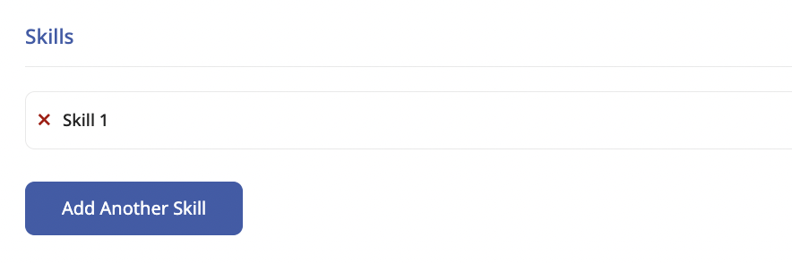
Your skills will be represented as such:
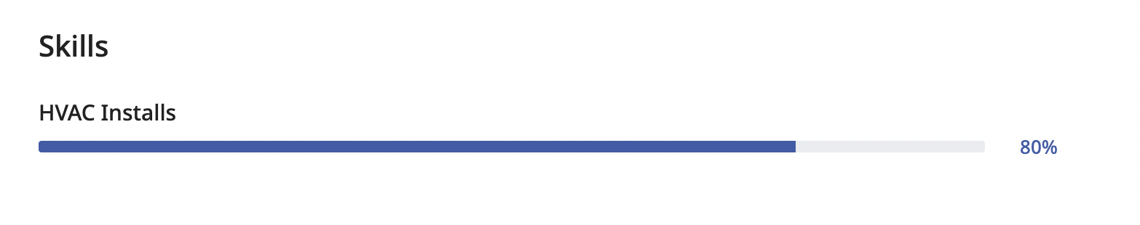

5. Engage with Employers:

Be quick to reply to messages and inquiries from employers. Show enthusiasm and actively participate in conversations with potential employers. Demonstrating your eagerness to work is important. Employers will appreciate your responsiveness, and based on your interactions, you might even earn a great review!
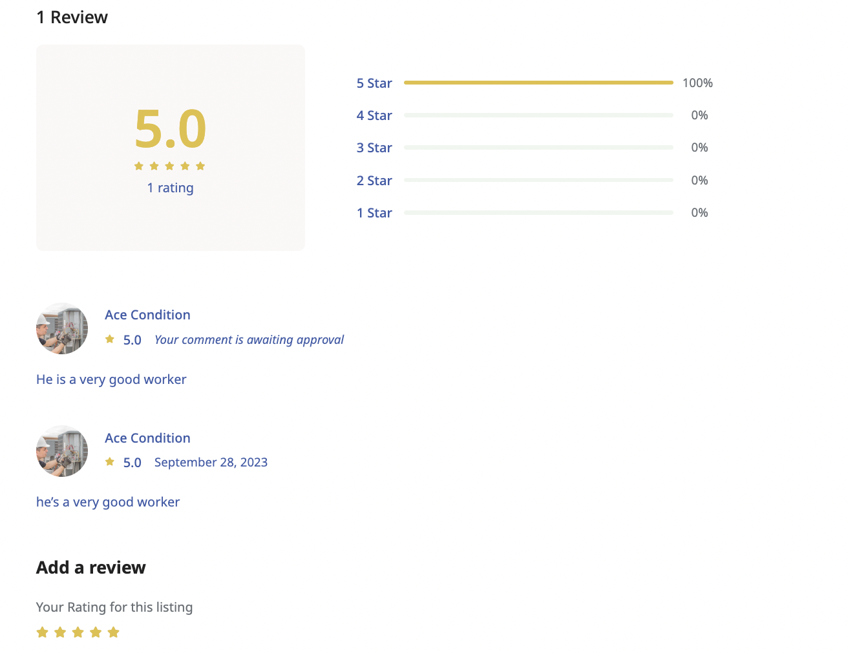

6. Keep Your Profile Updated:
Don't forget to keep your profile up-to-date. As you gain new skills and achieve new accomplishments, let everyone know!
By following these tips, you'll not only attract employers but also create a lasting impression. A well-crafted freelancer profile on Edvizing can be the gateway to the career of your dreams.

